PROGRESSIVE DAMAGE ANALYSIS OF COMPOSITE

LAMINATES WITH BIG CUTOUTS 1）

Chu Pengcheng, Li Zheng2), Chen Jianlin

(*College of engineering & LTCS, Peking university*，*Beijing 100871，China* )

**Abstract：**Composite materials have been increasingly used in practical engineering, many of which are designed as large aperture composite laminates, such as aircraft gates and portholes. Due to its complex stress state and the effect of stress concentration, coupled with the anisotropic nature of the composite material itself, various complex failure modes are produced, which leads to the difficulty in predicting the damage of laminates with big cutouts. In this paper, the progressive damage model is used to numerically simulate the damage of composite laminates with different cutouts and different layup under tensile loading. The Hashin criterion is used to judge whether the laminate has been damaged, and the continuum damage model(CDM) is used to simulate the progressive failure process of the damaged laminate. At the same time, shear nonlinear theory is introduced to perfect the model. We use ABAQUS finite element software, through the UMAT subroutine program written in Fortran to introduce progressive failure calculation model, calculate the ultimate load of the composite laminates with big cutouts, and simulate the entire process from the initial failure to complete failure of the laminate. Comparing the calculated results with the experimental results, the damage evolution mechanism and rules in the process of laminate destruction can be finally obtained. It also verifies that the calculation method in this paper can accurately predict the ultimate load and damage behavior of composite laminate with big cutouts under tensile load.

**Key words**：composite laminate, big cutout, progressive failure, continuum damage model, shear nonlinearity

**Introduction**

Because composite materials have the advantages of high specific strength, designability, fatigue resistance, and high temperature performance[1], they are widely used in aerospace, energy, transportation, construction and other engineering fields. At the same time, the composite laminates containing holes are also widely used in engineering, such as the bolt holes at the joints of laminates and the observation holes and bleed holes on aircraft engines. In addition, in order to meet the actual functions and requirements in production, there are a large number of structures designed to be laminates with big cutouts, such as aircraft fuselage doors and windows. However, it is unavoidable that it causes damage and failure to the structure during use. Composite materials have non-uniformity and anisotropy, and their destruction process is very complicated. There are four main types of composite material damage: 1 matrix cracking 2 interface debonding 3 delamination 4 fiber breakage. Sometimes different combinations of these four types of damage can form a comprehensive damage. As the damage area and size continue to increase, macroscopic cracks develop and expand, eventually resulting in final failure of the structure. For composite laminates with big cutouts, the internal stress state is more complicated. At the same time, due to the concentration of stress at the edge of the cutout and the discontinuity of the fiber at the cutout, the evolution process of the damage and the failure mode are further complicated. Therefore, it is very important and meaningful to accurately predict the damage state and ultimate load of composite laminates with big cutouts and explore the mechanism of damage for the safety and reliability of composite materials in engineering applications[2, 3].

At present, the methods developed for the failure calculation of composite laminates with cutouts fall into two major categories: analytical analysis and numerical calculation. The classic method of analytical analysis is to use fracture mechanics-based methods to predict the failure of laminates. For example, Whitney and Nuismer[4] proposed two methods for calculating the tensile strength of composite laminates based on the stress field distribution using characteristic scales: point stress method and average stress method. This method, without the need for complex calculations, has successfully predicted the failure of laminates under stress concentration, and also accurately simulated the size effect of laminates. However, this method based on fracture mechanics requires a large amount of experimental data, and most theories can only be used to calculate open laminates for a specific layup. At the same time, its limitation is that it only applies to composite laminates with small cutouts. As soon as the size of the cutout of the laminate increases, many assumptions of fracture mechanics no longer hold, then this method is no longer suitable.

Analytic methods in damage theory are not applicable to composite laminates where the stress state is more complex. On the other hand, the limitation of this method is that they can only calculate the ultimate load of laminates and cannot simulate the damage process of laminates. To understand the mechanism of composite laminates with big cutouts from initial damage to complete destruction, numerical damage analysis methods are clearly more applicable.

In numerical damage theory, a common analysis method is to use a progressive damage model. A large number of experimental data show that the failure of composite laminates is usually a gradual process, so we can see the gradual degeneration of stiffness as a function of failure modes. The study of Ochoa and Reddy [5] shows us the basic steps of progressive damage analysis of composite materials, as shown in Figure 2. This type of method usually consists four main steps[6]: (I) Strain and stress analysis in single layer of laminates. The key issue here is the establishment of the constitutive equations. Usually we use the finite element method to perform this step of calculation. (II) We use the failure criterion to determine whether the lamina has failed. Different researchers have proposed many different failure criteria, including the well-known maximum stress criterion, Tsai-Wu criterion[7], Hashin-Rotem criterion[8], and Puck criterion[9]. If it is judged that the material has not failed, then continue to increase the load to repeat the above calculation, if there is a failure, proceed to the next step; (III) the progressive failure analysis after the material has failed. The material stiffness of a single layer that has failed is reduced. The commonly used methods for this step are the ply discount method[10] and the continuum damage method[11] method, which will be described in detail below; (IV) Judging the complete failure of the laminate structure.. Some researchers believe that when the fiber damage occurs in each layer of the laminate, the laminate completely fails. However, this does not hold true in the case of stress concentration. For example, in open laminates, local fiber breaks can actually relieve stress concentration[12]. Camanho et al[13] believe that when the failure of the laminates expands to its boundary, the laminate fails completely. This paper uses this method to determine the ultimate failure of the laminate.

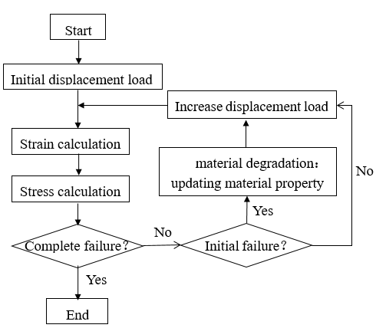

Fig.1 Progressive damage analysis process

From the above discussion, it can be seen that the analytic analysis method is often not applicable to composite laminates with big cutouts where the stress state is more complex. On the other hand, the limitation of these method is that they can only calculate the ultimate load of laminates and cannot simulate the failure process of laminates. To understand the mechanism of composite laminates with big cutouts from initial damage to complete destruction, numerical damage analysis methods are clearly more applicable. The numerical calculation method based on the continuous damage model and the finite element method is applicable to the damage analysis of any structure under any load form. It effectively compensates for the shortcomings of the analytical methods.

In the CDM, we describe the internal damage of composite material by defining one or more internal state variables, and set the coefficients in the constitutive relation as a function of one or more internal state variables. Krajcinovic[11] first proposed the idea of ​​CDM, describing it as a branch of continuous solid mechanics, in which the internal field variables represent the distribution of local microcracks. Shahid[14] and other scholars[15-16] applied this model earlier to composite laminates. Maimí[17] used the CDM to predict the initiation and evolution of the failure within the composite layer and the ultimate damage of the structure. Lapczyk et al[18] used the Hashin criterion and the CDM to predict the failure and post-failure behavior of the fiber-reinforced composites and calculate the elasto-brittle fracture behavior. Lee and Kim et al[19] evaluated the initial and progressive failures of glass/carbon fiber reinforced composite laminates based on the puck criterion and damage mechanics methods, and obtained results that are in good agreement with the experimental results.

The continuous damage model based on the theory of damage mechanics effectively avoids the uncertainty of the material degradation coefficient in the ply-discount model. All of the parameters it uses have a clear physical meaning and can all be measured directly and have proven to be a more effective and reliable method of simulating laminate damage.

At present, the damage study of composite laminates is concentrated in laminates without cutouts or small cutouts, but for composite laminates with big cutouts, there is a relative lack of simulations and calculations. Moreover, the damage of composite materials in the past is often focused on the prediction of the ultimate load, and the mechanism of the entire process from the initial failure to the complete failure is less studied, and this is exactly the limitations of some analytical methods.

In this paper, the progressive damage model which is formed by Hashin criteria and CDM is used to numerically simulate the damage of composite laminates with different cutouts and different layup under tensile loading. Through the comparative analysis of experiments and calculations, the ultimate load and damage evolution process of the composite laminates with big cutouts were obtained, the damage mechanism was revealed, and the reliability of the calculation model was also verified.

**1 渐进破坏分析模型**

**1.1失效准则**

复合材料的强度准则是判断材料是否损伤的依据，本文选用Hashin-Rotem准则来对大开口层合板的损伤进行判断，它作为一种与失效模式相关的失效准则，将复合材料的失效分为纤维拉伸(ft)，纤维压缩(fc)，基体拉伸(mt)和基体压缩(mc)4种损伤模式。即

(I)纤维拉伸失效：

|  |  |  |
| --- | --- | --- |
|  | $${f_{ft}=\left(\frac{σ_{11}}{X_{T}}\right)}^{2}≥1 (σ_{11}>0)$$ | (1) |

(II)纤维压缩失效：

|  |  |  |
| --- | --- | --- |
| $${f_{fc}=\left(\frac{σ_{11}}{X_{C}}\right)}^{2}≥1 (σ_{11}<0)$$ |  | (2) |

(III)基体拉伸失效：

|  |  |  |
| --- | --- | --- |
| $${f_{mt}=\left(\frac{σ_{22}}{Y_{T}}\right)}^{2}+{\left(\frac{σ_{12}}{S_{12}}\right)}^{2}≥1 (σ_{22}>0)$$ |  | (3) |

(IV)基体压缩失效：

|  |  |  |
| --- | --- | --- |
| $${f_{mc}=\left(\frac{σ_{22}}{Y_{C}}\right)}^{2}+{\left(\frac{σ_{12}}{S_{12}}\right)}^{2}≥1 (σ_{22}<0)$$ |  | (4) |

式中，*XT*（*XC*）为单层板在纤维方向上的拉伸（压缩）强度；*YT*（*YC*）为单层板在基体方向上的拉伸（压缩）强度；*S*12为单层板的横向剪切强度。

**1.2损伤本构方程**

一旦材料达到强度准则的条件，接下来就会造成材料刚度系数的退化。本文使用连续损伤模型来计算材料刚度系数的衰减，当材料出现破坏时，材料的本构关系由损伤刚度矩阵 $C$ 定义:

$$C=\frac{1}{D}\left[\begin{matrix}(1-d_{1})E_{1} & (1-d_{1})(1-d_{2}){ν_{21}E}_{1} & 0 \\ (1-d_{1})(1-d_{2}){ν_{12}E}_{2} & (1-d_{2})E_{2} & 0 \\ 0 & 0 & D(1-d_{6})G_{12}\end{matrix}\right]$$

(5)

式(5)中的 $d_{1}$， $d_{2}$ 和 $d_{6}$ 为损伤变量，都属于标量，它们的设置是为了维持材料在损伤情况下的对称性。损伤变量 $d_{1}$ 和纵向（纤维）的失效相关， $d_{2}$ 和横向（基体）的失效相关，而 $d_{6}$ 同时受到横向以及纵向裂纹的影响。*D*表达式为： $D=1-\left(1-d_{f}\right)\left(1-d_{m}\right)ν_{12}ν_{21}$，参数 $E_{1}$， $E_{2}$ 和 $G_{12}$ 分别为材料未损伤时材料的弹性模量， $ν_{21}$， $ν_{12}$ 为未损伤时材料的泊松比。

**1.3损伤演化**

损伤的演化过程受到损伤变量的控制，在从损伤开始到材料完全破坏的过程中，损伤变量由0（未损伤状态）逐渐变为1（完全破坏）。学者们提出了不同的损伤变量演化法则来模拟材料损伤时的软化过程，例如Camanho[17]等人提出了使用指数形式的演化法则来表征失效的规律，而Lapczyk[18]等人则假设损伤的演化过程遵循线性的法则。不同形式退化法则适用于不同的材料，如图2所示。在本文的计算中，分别采用了指数和线性两种演化法则对损伤变量进行退化，并对计算的结果进行了对比。这里我们取四个损伤变量分别对应Hashin准则中的四个损伤模式，*ft*和*fc*分别表示纤维的拉伸和压缩破坏，*mt*和*mc*分别表示基体的拉伸破坏。根据线性和指数演化法则所列出表达式分别为：

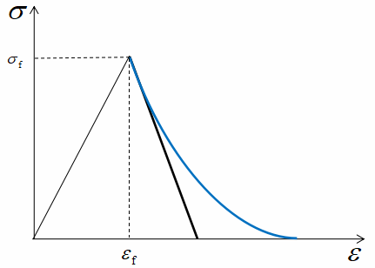

图2 损伤演化法则（黑色：线性法则；蓝色：指数法则）

Fig.2 Damage evolution law (black: linear law; blue: exponential law)

（I）线性演化

$d_{I}=A\left(1-\frac{1}{f_{I}}\right) I∈\left\{ft,fc,mt,mc\right\}$ (6)

（II）指数演化

$d_{I}=1-\frac{1}{f_{I}}e^{A\left(1-f_{I}\right) } I∈\left\{ft,fc,mt,mc\right\}$ (7)

其中*A*是与强度及断裂能有关的材料参数构成的表达式， $f_{I}$ 分别对应式(1)~(4)中的四个不同失效模式下的失效准则表达式。对能量耗散率进行积分，可以得到单向应力状态下单元体积内的能量耗散值 $g_{I}$：

$g_{I}=\int_{1}^{∞}{\frac{∂G}{∂d_{I}}\frac{∂d_{I}}{∂f_{I}}df_{I} I∈\left\{ft,fc,mt,mc\right\}}$ (8) 通过式(8)，可以计算出(6)和(7)中的参数*A*，从而确定损伤变量 $d_{I}$ 的表达式。

**1.4 消除网格依赖性的特征长度法**

由于计算中材料会出现应变软化行为，导致应变的局域化，致使有限元的结果会产生强烈的网格依赖性。Lapczyk[18]通过杆的单向拉伸的算例，已经说明了耗散能的结果与失效单元的体积成正比的现象。为了避免结果中出现不同单元尺寸得到不同耗散能的情况，他使用了Bažant等人[20]提出的裂纹带模型。在此模型中，断裂被模拟为一条平行紧密分布的微裂纹带。为了消除网格的依赖性，引入单元的特征长度，从而对计算得到的耗散能进行正则化，即

$g_{I}=\frac{G_{I}}{L_{c}} I∈\left\{ft,fc,mt,mc\right\}$ (9)

式中的 $G_{I}$ 为断裂能， $L_{c}$ 为单元的特征长度， $g_{I}$ 为单元体积内的断裂能。结合式(8)，可以得到：

$\int_{1}^{∞}{\frac{∂G}{∂d_{I}}\frac{∂d_{I}}{∂f_{I}}df_{I}=\frac{G_{I}}{L_{C}} I∈\left\{ft,fc,mt,mc\right\}}$ (10)

结合式(6)、(7)和(10)，可以得到线性演化和指数演化两种模型下的损伤变量的具体表达式：

（I）线性演化

$d_{fM}=\frac{2G_{f}C_{11}}{2G_{f}C_{11}-X_{fM}^{2}L_{C}}\left(1-\frac{1}{f_{fM}}\right) M∈\left\{t,c\right\}$ (11)

$d_{mM}=\frac{2G_{m}C_{22}}{2G_{m}C_{22}-Y_{mM}^{2}L_{C}}\left(1-\frac{1}{f_{mM}}\right) M∈\left\{t,c\right\}$ (12)

（II）指数演化

$d_{fM}=1-\frac{1}{f_{fM}}e^{\frac{X_{fM}^{2}L_{C}}{C_{11}G_{f}}\left(1-f_{fM}\right) } M∈\left\{t,c\right\}$

(13)

$d_{mM}=1-\frac{1}{f_{mM}}e^{\frac{Y_{mM}^{2}L_{C}}{C_{22}G_{m}}\left(1-f_{mM}\right) } M∈\left\{t,c\right\}$

(14)

其中， $G_{f}$ 和 $G_{m}$ 分别为纤维和基体的断裂能，下标中的字母*M*为*t*或*c*分别表示拉伸或者压缩状态。 $C_{ij}$ 为刚度矩阵的系数。

**1.4 剪切非线性**

在一般情况下，我们在考虑复合材料的应力应变关系时，只考虑线弹性的本构方程. 然而，近年来大量的实验数据表明，在层合板的力学性能中存在着非线性的现象。在Puck等人[9]的研究中，就用大量的实验结果向我们展示了复合材料在各种类型载荷作用下应力应变关系出现非线性的现象。在诸多非线性的研究中，最能表明非线性效应所产生影响的是最常见的平面剪切实验[21-23]。复合材料中的剪切非线性已经广泛地被接受，有许多学者在材料建模中都考虑了剪切非线性效应[24-26]。其中，刘魏光等人[27]使用了Ramberg-Osgood方程[28]拟合了剪应变和剪应力之间的非线性关系，具体表达式如下：

$τ=\frac{G_{0}γ}{{\left[1+{\left(G_{0}γ/τ_{0}\right)}^{n}\right]}^{1/n}}$ (15)

式中的 $τ$ 和 $γ$ 分别为剪应变和剪应力， $G_{0}$ 为初始剪切模量， $τ_{0}$ 为极限剪切强度，*n*是定义了剪切非线性关系曲线形状的参数。由式(15)可以得到考虑剪切非线性后的复合材料的本构关系：

$$\left[\begin{matrix}σ_{1} \\ σ_{2} \\ τ\end{matrix}\right]=\left[\begin{matrix}\frac{E_{1}}{1-ν_{12}ν_{21}} & \frac{ν_{21}E_{2}}{1-ν_{12}ν_{21}} & 0 \\ \frac{ν_{12}E_{1}}{1-ν_{12}ν_{21}} & \frac{E_{2}}{1-ν_{12}ν_{21}} & 0 \\ 0 & 0 & \frac{G_{0}}{{\left[1+{\left(G_{0}γ/τ_{0}\right)}^{n}\right]}^{1/n}}\end{matrix}\right]\left[\begin{matrix}ε_{1} \\ ε_{2} \\ γ\end{matrix}\right]$$

(16)

在本文数值模拟中，在复合材料层合板发生初始失效之前，材料中的本构模型按照式(16)进行计算。一旦复合材料某区域开始出现损伤，则该区域的本构模型如式(5)所示。

**2 大开孔层合板的破坏数值模拟**

**2.1大开孔层合板的损伤演化模拟**

本文使用ABAQUS有限元软件，并通过Fortran语言编写UMAT子程序引入前文介绍的渐进失效计算模型，对拉伸载荷下下三种不同铺层以及三种不同孔径的大开孔复合材料层合板进行数值模拟。三种铺层的方式分别为 ${[0]}_{10}$ 单向铺层， ${[0/90]}_{5}$ 正交铺层， ${[45/-45]}_{5}$ 角对称铺层。同时每种铺层的层合板又分为60mm、80mm和100mm三种不同的开孔孔径。层合板尺寸均为240mm×160mm× 1.58mm，加载的方式为单向拉伸，如图3所示。

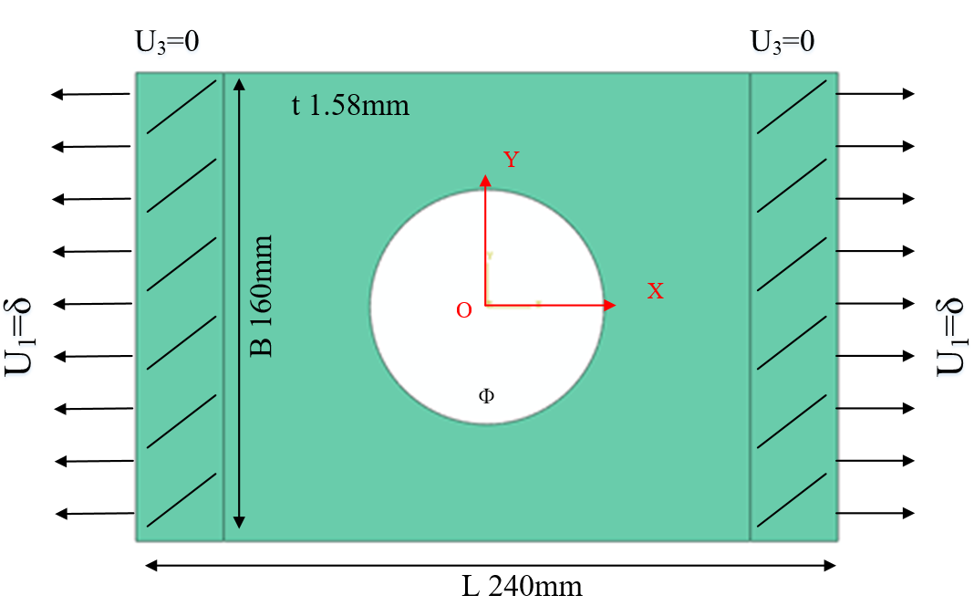

图3 数值模型

Fig.3 Simulation model

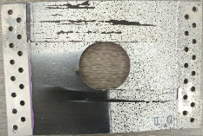 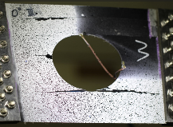 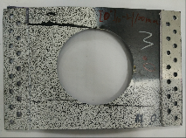

1. [0]10大开孔层合板

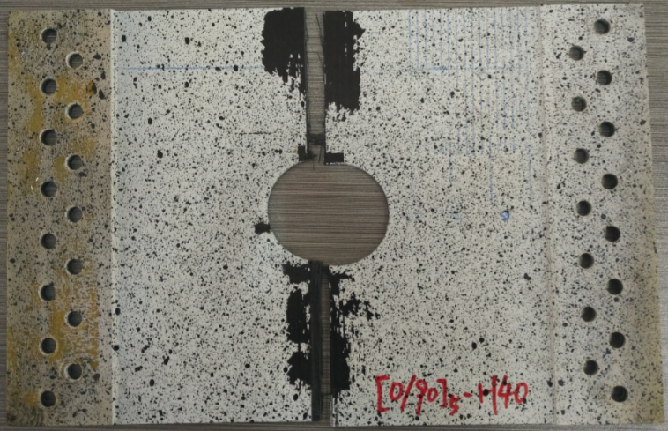 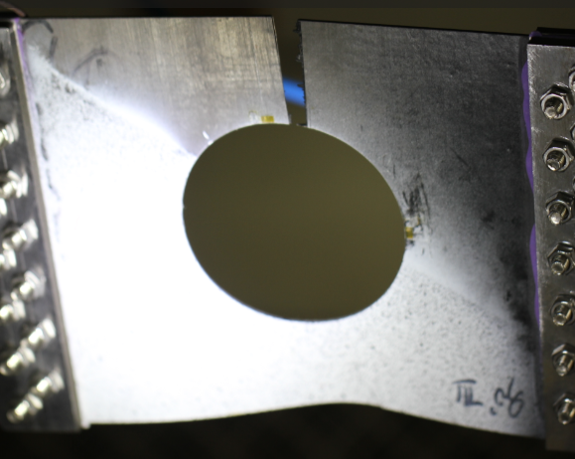 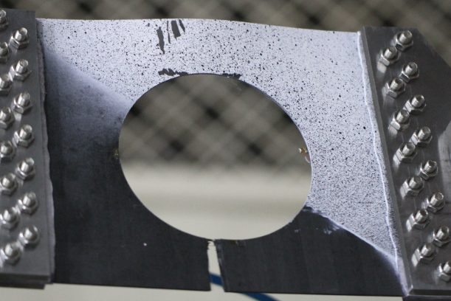

1. [0/90]5大开孔层合板

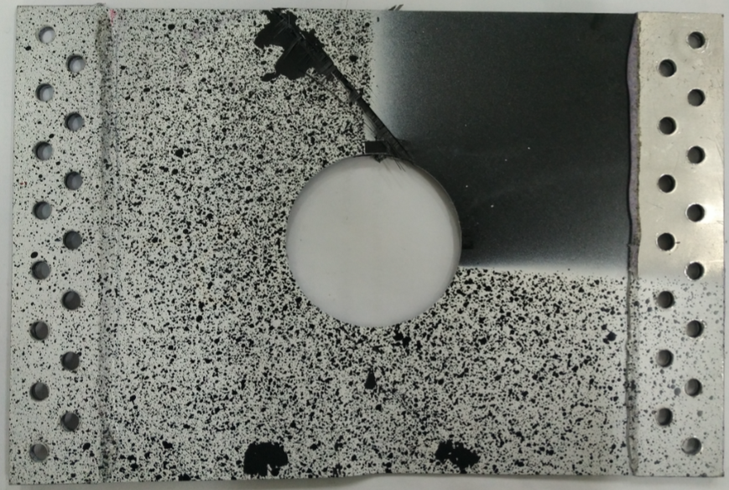 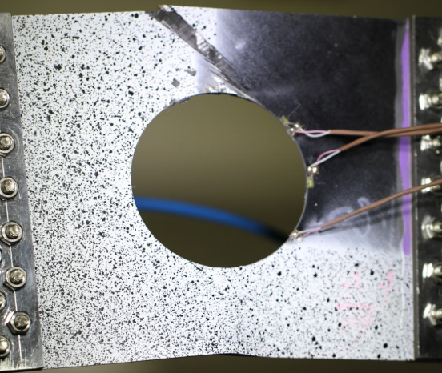 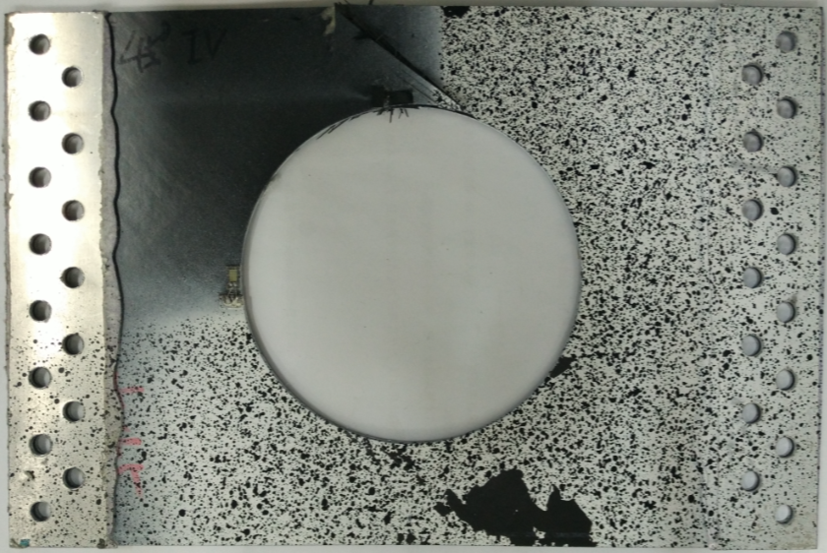

1. [±45]5大开孔层合板

图9 [±45]5大开孔层合板损伤演化实验结果

Fig.9 Failure evolution experiment result of [±45]5 laminate with cutout

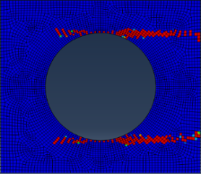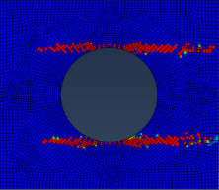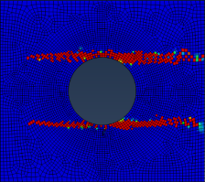

Ф=60mm Ф=80mm Ф=100mm

图4 [0]10大开孔层合板损伤演化模拟结果

Fig.4 Failure evolution simulated result of [0]10 laminate with cutout

图4展示的是三种孔径的[0]10单向层合板在拉伸破坏过程中拍摄的试件照片。通过将模拟的结果和图9a中的实验结果进行对比，我们可以发现[0]10单向层合板在单向拉伸载荷的作用下，在应力集中处开始出现了初始损伤，损伤模式为基体拉伸损伤。此损伤随着载荷的增加沿着拉伸的方向进行扩展，直至损伤裂纹到达复合材料层合板的边界处。此时的拉伸载荷达到了材料的极限载荷，材料的承载能力急剧下降。

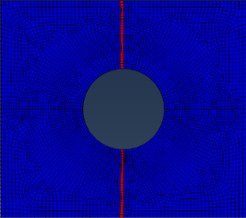 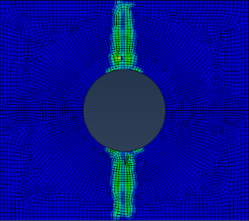

(I)纤维失效 (II)基体失效

(a) 0°层失效演化

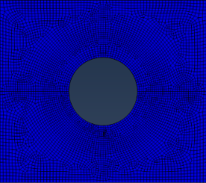 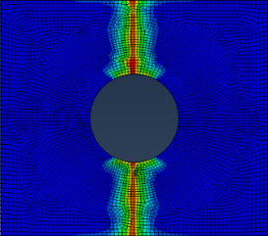

(I)纤维失效 (II)基体失效

(b) 90°层失效演化

图5 60mm孔径[0/90]5大开孔层合板失效演化模拟结果

Fig.5 Failure evolution simulated result of [0/90]5 laminate with 60mm cutout

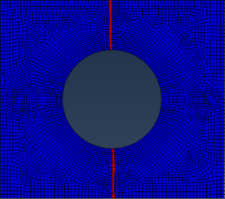 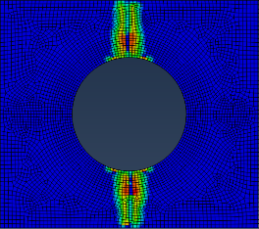

(I)纤维失效 (II)基体失效

(a) 0°层失效演化

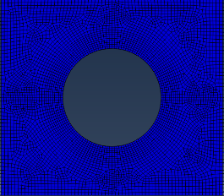 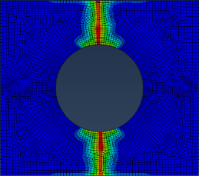

(I)纤维失效 (II)基体失效

(b) 90°层失效演化

图6 80mm孔径[0/90]5大开孔层合板失效演化模拟结果

Fig.6 Failure evolution simulated result of [0/90]5 laminate with 80mm cutout

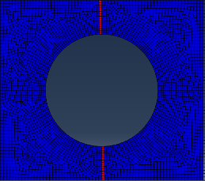 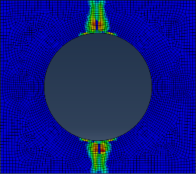

(I)纤维失效 (II)基体失效

(a) 0°层失效演化

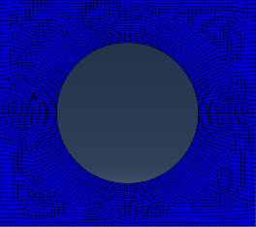 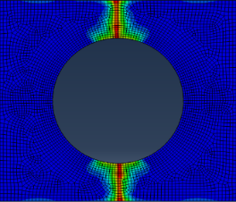

(I)纤维失效 (II)基体失效

(b) 90°层失效演化

图7 100mm孔径[0/90]5大开孔层合板失效演化模拟结果

Fig.7 Failure evolution simulated result of [0/90]5 laminate with 100mm cutout

图7展示的是三种孔径的[0/90]5正交层合板在拉伸破坏过程中拍摄的试件照片。通过将模拟的失效演化图和图9b中的实验结果进行对比，我们可以发现正交铺层层合板在单向拉伸载荷的作用下，出现的第一处损伤是在90°层的基体拉伸损伤，失效的位置为孔边的应力集中处。随着载荷的继续增大，在0°层先后出现了基体拉伸损伤和纤维拉伸损伤，起始损伤同样发生在孔边的应力集中处，此两种损伤都同时沿着与拉伸方向垂直的方向扩展。而在90°层上，基体拉伸失效也沿着与拉伸方向垂直的方向同步扩展，但是并没有纤维失效发生。最终0°层的纤维失效和90°层的基体失效几乎同时扩展至边界，意味着结构的彻底失效。

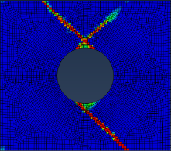 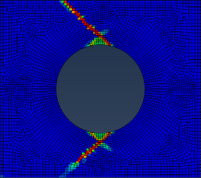 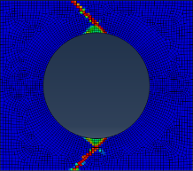

Ф=60mm Ф=80mm Ф=100mm

图8 [±45]5大开孔层合板损伤演化模拟结果

Fig.8 Failure evolution simulated result of [±45]5 laminate with cutout

图8展示的是三种孔径的[45/-45]5角对称铺层层合板在拉伸破坏过程中拍摄的试件照片。通过将模拟的结果和图9c中的实验结果进行对比，可以总结出角对称铺层层合板的失效过程。在单向拉伸载荷的作用下，初始损伤出现在孔边应力集中的位置，损伤的模式为基体拉伸损伤。而后，随着载荷的增加，损伤沿着拉伸方向45°向边界扩展，直到结构达到极限载荷。进一步地加载，将造成结构彻底失效。

综合整个损伤的演化可以看出，三种铺层的大开孔复合材料层合板在单向拉伸载荷下的损伤演化过程各不相同，并且均不受开孔大小的影响。而不同铺层的层合板出现的失效模式也各不相同，比如[±45]5铺层层合板只出现了基体失效，而[0/90]5铺层层合板中同时出现了基体和纤维的失效。上述的计算结果也验证了本文使用的计算模型的准确性，使用线性退化和指数退化两种模型都能比较准确的模拟出角铺层层合板的拉伸损伤演化过程。

**2.2大开孔层合板的失效载荷计算**

通过数值模拟还可以得到拉伸过程中的载荷变化情况，图10给出了 ${[0]}_{10}$ 单向铺层， ${[0/90]}_{5}$ 正交铺层， ${[45/-45]}_{5}$ 角对称铺层三种铺层的不同孔径的层合板在单向拉伸过程中的位移载荷曲线，其中实线和虚线分别代表线性退化模型和指数退化模型。

从计算结果可以看出，各铺层的大开孔复合材料层合板在单向拉伸载荷下的失效为脆性断裂行为，而数值计算得到的结果显示出，不论是线性退化模型还是指数退化模型都能比较准确的模拟出脆性断裂的性质。

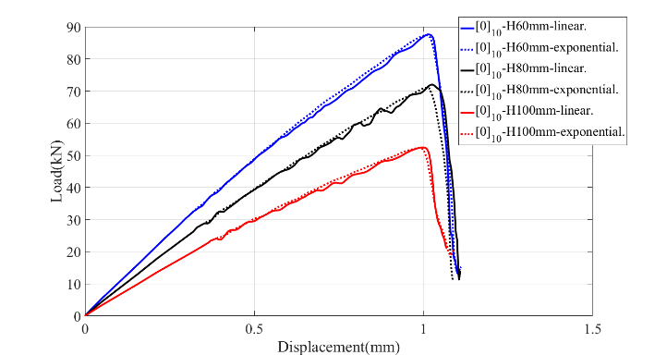

1. [0]10铺层

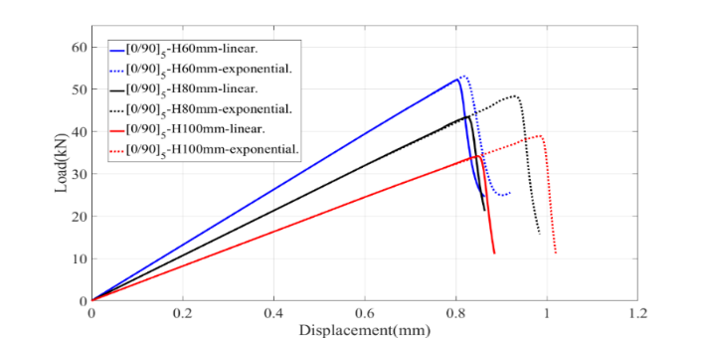

1. [0/90]5铺层

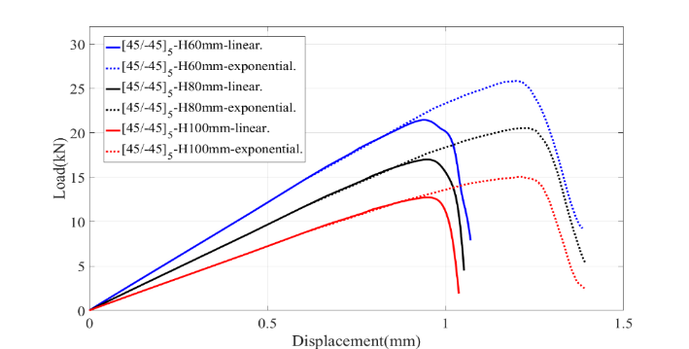

1. [±45]5铺层

图10 各开口层合板的载荷-位移曲线计算结果

Fig.10 Load-Displacement curve calculation result of laminates with big cutouts

表1、表2 以及表3分别展示了 ${[0]}_{10}$ 单向铺层， ${[0/90]}_{5}$ 正交铺层， ${[45/-45]}_{5}$ 角对称铺层三种层合板的极限载荷的计算结果和实验结果的对比。每种铺层层合板有三种不同的孔径，每张表都给出了使用线性退化和指数退化两种模型计算所得到的结果和实验结果的误差对比。从各表中数据可以看出，最大的误差出现在100mm孔径的 ${[0]}_{10}$ 单向铺层单向层合板中，这是由于在实验中出现了局部屈曲的线性，而本文的计算模型并没有考虑屈曲的影响。初此以外，其他极限载荷计算结果的的误差均在30%以内，指数退化模型计算结果的误差小与线性退化模型。

表1 [0]10铺层层合板的极限载荷计算结果

Table.1 Ultimate Loading calculation result of [0]10 laminates

|  |  |  |  |  |  |  |
| --- | --- | --- | --- | --- | --- | --- |
| 退化模型 | 60mm | | 80mm | | 100mm | |
| 计算  结果  (KN） | 误差  (%) | 计算  结果  (KN) | 误差  (%) | 计算  结果  (KN) | 误差(%) |
| 线性退化 | 87.60 | 11.98 | 72.00 | 3.26 | 52.42 | 49.77 |
| 指数退化 | 87.36 | 11.67 | 71.05 | 1.89 | 52.31 | 49.46 |

表 2 [0/90]5铺层层合板的极限载荷计算结果

Table.2 Ultimate Loading calculation result of [0/90]5 laminates

|  |  |  |  |  |  |  |
| --- | --- | --- | --- | --- | --- | --- |
| 退化模型 | 60mm | | 80mm | | 100mm | |
| 计算  结果  (KN） | 误差  (%) | 计算  结果  (KN) | 误差  (%) | 计算  结果  (KN) | 误差(%) |
| 线性退化 | 52.11 | 12.15 | 43.30 | 8.05 | 34.16 | 9.00 |
| 指数退化 | 53.01 | 10.64 | 48.29 | 2.26 | 38.90 | 3.62 |

表 3 [±45]5铺层层合板的极限载荷计算结果

Table.3 Ultimate Loading calculation result of [±45]5 laminates

|  |  |  |  |  |  |  |
| --- | --- | --- | --- | --- | --- | --- |
| 退化模型 | 60mm | | 80mm | | 100mm | |
| 计算  结果  (KN） | 误差  (%) | 计算  结果  (KN) | 误差  (%) | 计算  结果  (KN) | 误差(%) |
| 线性退化 | 21.46 | 25.28 | 17.00 | 28.54 | 12.74 | 27.61 |
| 指数退化 | 25.86 | 9.96 | 20.56 | 13.58 | 15.05 | 14.49 |

图11总结了孔径宽度比和极限载荷之间的关系。由图中可以看出，对于相同铺层的层合板，极限载荷值随着开孔直径的增大而减小；而对于同一孔径的层合板而言，极限载荷由大到小的铺层为：[0]10单向铺层、 [0/90]5正交铺层以及[±45]5角对称铺层。这进一步说明了在复合材料层合板中，主要承载的是纤维，当拉伸方向的0°层的板在层合板中所占比例越多，层合板整体的承载能力也就越强，极限载荷也就越大。

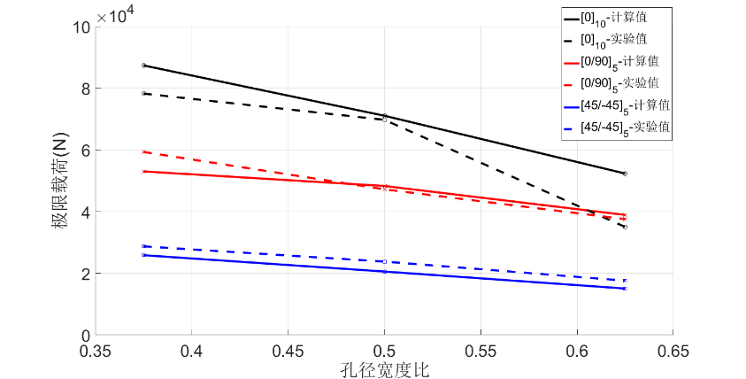

图11孔径宽度比和极限载荷关系图

Fig.11 Relationship between diameter width ratio and ultimate loading

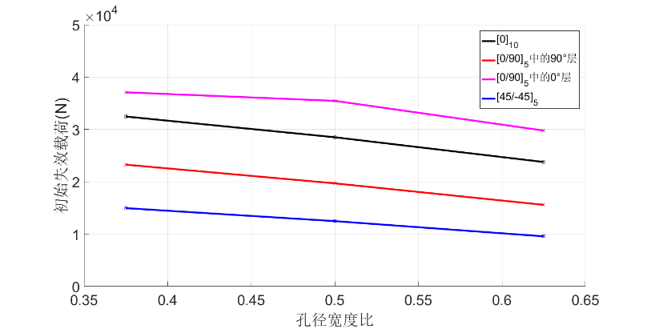

图12孔径宽度比和初始失效载荷关系图

Fig.12 Relationship between diameter width ratio and initial failure loading

图12展示了[0]10单向铺层层合板，[0/90]5正交铺层层合板和[45/-45]5角对称铺层层合板的初始失效载荷以及孔径宽度比之间的关系。由图中可得：三种铺层层合板在初始失效时的载荷随着孔径尺寸的增大均呈现减小的趋势。而当孔径宽度比相同时候，在拉伸载荷不断增加的过程中，[45/-45]5角对称铺层层合板将率先出现损伤，初始损伤模式为基体拉伸失效；[0/90]5正交铺层层合板第二个出现损伤，初始损伤模式为90°层上的基体拉伸损伤；最后发生损伤的铺层是[0]10单向铺层层合板，损伤模式同样是基体拉伸损伤。然而，[0/90]5正交铺层层合板中的0°层比[0]10单向层合板的0°层出现初始损伤时的载荷更大。这说明在[0/90]5正交铺层层合板中，由于90°层的存在，增加了0°层承受载荷的能力。

根据以上的分析可知，本文提出了计算模型可以比较准确地预测三种铺层层合板在单向拉伸载荷下的极限载荷。并且指数退化模型比线性退化模型的极限载荷计算结果更加精确，指数退化模型显然更加接近于真实的材料。

**2.2考虑剪切非线性的角对称层合板失效模拟**

从实验中，我们发现了[±45]5角铺层中的位移和载荷呈非线性的关系。为了准确地模拟出这种现象，我们考虑复合材料中的剪切非线性效应。我们使用上文中讨论过的Ramberg-Osgood方程来定义本构方程中的剪切非线性关系，并采用与前文相同的模型进行数值模拟。

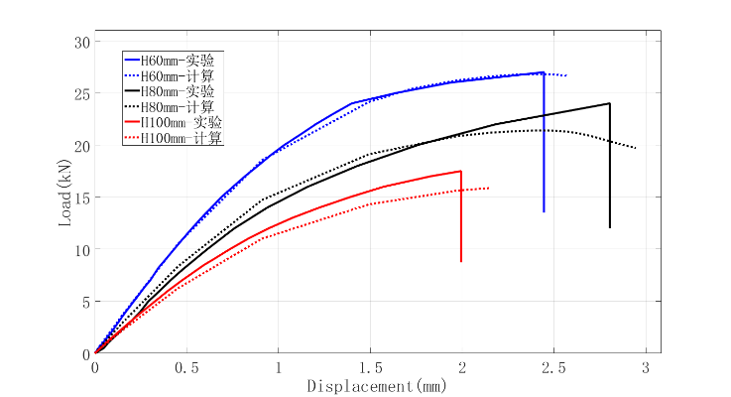

图11考虑剪切非线性后[45/-45]5角铺层层合板的位移-载荷曲线计算结果

Fig.11 Load-Displacement curve calculation result of [45/-45]5 laminates considering shear nonlinearity

图11给出了考虑剪切非线性后计算出的不同孔径的[45/-45]5角对称铺层层合板的位移载荷曲线和实验结果的对比，可以看出计算结果比较符合实验所得结果，能比较准确地模拟角对称铺层层合板在单向拉伸过程中出现的非线性现象。

表 4 [45/-45]5角对称铺层层合板使用剪切非线性前后的极限载荷对比

Table.4 Comparison of Limit Loads before and after Using Shear Nonlinearity for 45/-45]5 lanimates

|  |  |  |  |  |  |  |
| --- | --- | --- | --- | --- | --- | --- |
| 退化模型 | 60mm | | 80mm | | 100mm | |
| 计算  结果  (KN） | 误差  (%) | 计算  结果  (KN) | 误差  (%) | 计算  结果  (KN) | 误差(%) |
| 线性退化 | 25.86 | 9.96 | 20.56 | 13.58 | 15.50 | 14.49 |
| 指数退化 | 26.81 | 6.65 | 21.39 | 10.09 | 16.01 | 9.03 |

表4展示了考虑剪切非线性效应前后计算所得的极限载荷与实验结果的对比。从表中可以看出，考虑剪切非线性后，角对称铺层层合板的极限载荷比未使用剪切非线性时更加精确，这进一步说明了剪切非线性在数值模拟中的必要性。

**3 结 论**

本文基于Hashin-Rotem失效准则和连续损伤模型的理论，建立了渐进损伤模型。并且在有限元软件ABAQUS中通过编写UMAT子程序实现了这一模型，完整地实现了对多种铺层和多种孔径的大开孔复合材料层合板在单向拉伸载荷下从出现初始失效到彻底失效的全过程的模拟，并采用剪切非线性理论进一步完善了计算模型。研究结果表明：

（1）大开孔复合材料层合板在单向拉伸载荷下的破坏是一个脆性断裂过程，无论是实验还是计算结果都表明了这一现象。

（2）初始失效通常发生在应力集中区域中，并且初始失效发生时的载荷值随着孔径的增大而减小。而极限载荷受到铺层方式的影响。当纤维方向沿着拉伸方向的铺层在层合板中所占比例越多，承载的能力也就越强，极限载荷也就越大。而对于同一铺层的层合板，极限载荷随着孔径尺寸增大而减小。

（3）不同的铺层的损伤演化和破坏模式不同。对于同一铺层层合板而言，损伤的破坏模式并不受孔径大小的影响。而在损伤演化过程中，同一区域往往可以有不同模式的损伤同时发生。

（4）基于连续损伤模型的渐进失效分析可以有效地计算出大开孔复合材料层合板在单向拉伸载荷下的损伤演化过程以及极限载荷，而指数退化模型相比于线性退化模型可以更加准确地预测大开口层合板的极限载荷。对于[45/45]5角对称铺层层合板的计算，引入剪切非线性效应可使位移载荷曲线结果更加准确。

**参考文献**

1沈观林, 胡更开, 刘彬. 复合材料力学.第2版. 清华大学出版社, 2013.

2杜善义, 关志东. 我国大型客机先进复合材料技术应对策略思考. 复合材料学报, 2008, 25(1): 5-5.

3 Awerbuch J, Madhukar M S. Notched Strength of Composite Laminates: Predictions and Experiments--A Review. Journal of Reinforced Plastics & Composites, 1985, 4(1): 3-159.

4 Whitney J M, Nuismer R J. Stress Fracture Criteria for Laminated Composites Containing Stress Concentrations. Journal of Composite Materials, 1974, 8(3): 253-65.

5 Ochoa O O, Reddy J N. Finite Element Analysis of Composite Laminates. Nasa Sti/recon Technical Report A, 1992, 94(1): 37-109.

6黄争鸣, 张华山. 纤维增强复合材料强度理论的研究现状与发展趋势——"破坏分析奥运会"评估综述. 力学进展, 2007, 37(1): 80-98.

7 Tsai S W, Wu E M. A General Theory of Strength for Anisotropic Materials. Journal of Composite Materials, 1971, 5(1): 58-80.

8 Hashin Z, Rotem A. A Fatigue Failure Criterion for Fiber Reinforced Materials. Journal of Composite Materials, 1973, 7(4): 448-64.

9 Puck A, Schürmann H. Failure analysis of FRP laminates by means of physically based phenomenological models. Composites Science & Technology, 2002, 62(12–13): 1633-62.

10 Poon C, Shokrieh M M, Lessard L B. Three-Dimensional Progressive Failure Analysis of Pin/Bolt Loaded Composite Laminates. 1996,

11 Krajcinovic D K. Continuum damage mechanics. 1984, 37(1): 1-6.

12 Camanho P M P R D C. Application of numerical methods to the strength of mechanically fastened joints in composite laminates. Wear, 1999, 5(2): 114-35.

13 Camanho P P, Matthews F L. Stress analysis and strength prediction of mechanically fastened joints in FRP: a review. Composites Part A Applied Science & Manufacturing, 1997, 28(6): 529-47.

14 Shahid I, Chang F K. Accumulative damage model for tensile and shear failures of laminated composite plates. Journal of Composite Materials, 1995, 29(7): 926-81.

15 Chang F K, Chang K Y. A Progressive Damage Model for Laminated Composites Containing Stress Concentrations. Journal of Composite Materials, 1987, 21(9): 834-55.

16 Ladeveze P, Ledantec E. Damage modelling of the elementary ply for laminated composites. Composites Science & Technology, 1992, 43(3): 257-67.

17 Maimí P, Camanho P P, Mayugo J A, et al. A continuum damage model for composite laminates: Part II – Computational implementation and validation. Mechanics of Materials, 2007, 39(10): 909-19.

18 Lapczyk I, Hurtado J A. Progressive damage modeling in fiber-reinforced materials. Composites Part A Applied Science & Manufacturing, 2007, 38(11): 2333-41.

19 Lee C S, Kim J H, Kim S K, et al. Initial and progressive failure analyses for composite laminates using Puck failure criterion and damage-coupled finite element method. Composite Structures, 2015, 121(406-19.

20 Bažant Z P, Oh B H. Crack band theory for fracture of concrete. Matériaux Et Construction, 1983, 16(3): 155-77.

21 Chamis C C, Sinclair J H. Ten-deg off-axis test for shear properties in fiber composites. Experimental Mechanics, 1977, 17(9): 339-46.

22 Swanson S R, Messick M, Toombes G R. Comparison of torsion tube and Iosipescu in-plane shear test results for a carbon fibre-reinforced epoxy composite. Composites, 1985, 16(3): 220-4.

23 Weinberg M. Shear testing of neat thermoplastic resins and their unidirectional graphite composites. Composites, 1987, 18(5): 386-92.

24 Hahn H T, Tsai S W. Nonlinear Elastic Behavior of Unidirectional Composite Laminae. Journal of Composite Materials, 1973, 7(1): 102-18.

25 Paepegem W V, Baere I D, Degrieck J. Modelling the nonlinear shear stress–strain response of glass fibre-reinforced composites. Part I: Experimental results. Composites Science & Technology, 2006, 66(10): 1455-64.

26 Chang F K, Lessard L B. Damage Tolerance of Laminated Composites Containing an Open Hole and Subjected to Compressive Loadings: Part I--Analysis. Journal of Composite Materials, 1991, 25(1): 44-64.

27刘魏光, 余音, 汪海. 考虑剪切非线性的复合材料渐进损伤模型. 上海交通大学学报, 2016, 50(2): 194-9.

28 Blacklock J R, Richard R M. Finite element analysis of inelastic structures. Aiaa Journal, 2015, 7(7):432-438.